Unit 3
Lesson 2 – Me and my school
- 1 a) Look at the flags.
Pogledaj ove zastave.
Read the names of the countries they represent.
Pročitaj kojim državama pripadaju.
Find these countries with a help from your teacher.
Uz pomoć učiteljice pronađi te države na karti.

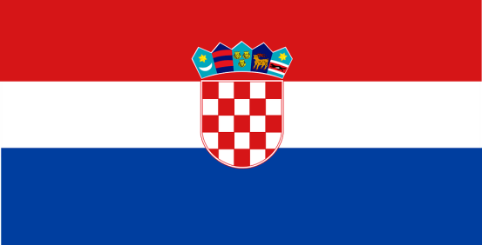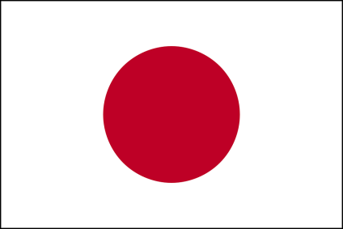

Croatia United Kingdom Japan Ethiopia
Hrvatska Ujedinjeno kraljevstvo Japan Etiopija

b) Write the names of the countries in the empty frames.
Upiši imena država kojima pripadaju zastave u okvire.
Are these countries far away from each other?
Jesu li te države blizu ili daleko jedna od druge?
How would you travel to get there?
Kojim bi prijevoznim sredstvom putovao/la u te zemlje?

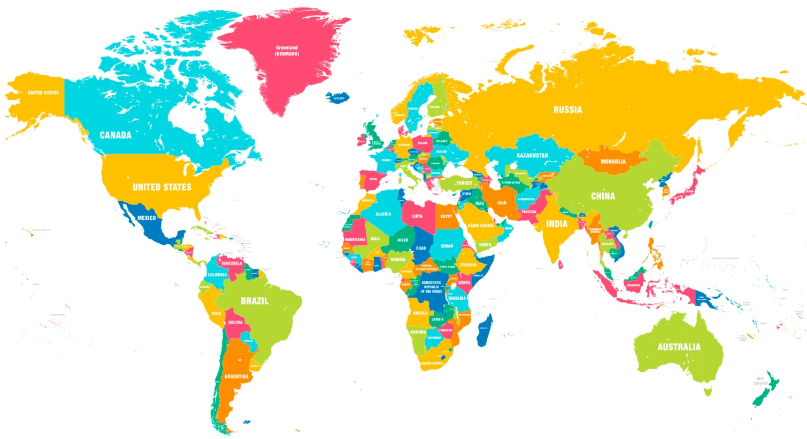

TOSHIO
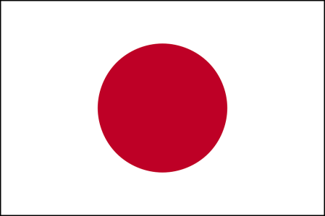

- 2
a) Look at the pictures.
Pogledaj sličice.
Where does Toshio come from?
Odlakle je Toshio?

b) Listen to your teacher read the text.
Poslušaj svog učitelja kako čita tekst.

c) Read the text together with your teacher.
Pročitaj tekst zajedno sa svojim učiteljem.

What does Toshio want to be?
Što Toshio želi postati kad odraste?

TOSHIO
Hi there. My name is Toshio. It means genius.
Bok! Moje ime je Toshio. To znači genijalac.




I am crazy about computers and IT.
Zaluđen sam računalima i informatikom.

I go to a computer club.
Pohađam računalnu grupu.

I’d like to be an engineer.
Volio bih postati inženjer.

* Toshio wants to be _____________________________ .
(Toshio želi biti…)

d) Match the words to their meaning.
Spoji riječi s njihovim značenjem.

A) IT 1 programiranje
B) genius 2 inženjer
C) programming 3 računalna grupa
D) engineer 4 informacijske tehnologije
E) computer club 5 genijalac

e) Match the beginnings of the sentences with the endings.
Upari početak rečenice s krajem.

1 Toshio means a) more fun than playing
games.
2 He likes playing b) genius.
3 He goes to a c) computer club.
4 Toshio is crazy about d) computer games.
5 He thinks programming is e) computers and IT.
6 Toshio would like to be f) an engineer.

- 3 RHEA
a) Look at the pictures.
Pogledaj sličice.
Where does Rhea come from?

Odlakle je Rhea?
b) Listen to your teacher read the text.
Poslušaj svog učitelja kako čita tekst.
c) Read the text together with your teacher.
Pročitaj tekst zajedno sa svojim učiteljem.
What does Rhea want to be?
Što Rhea želi postati kad odraste?
RHEA
Hi everyone. My name is Rhea.
Bok svima. Moje ime je Rhea.
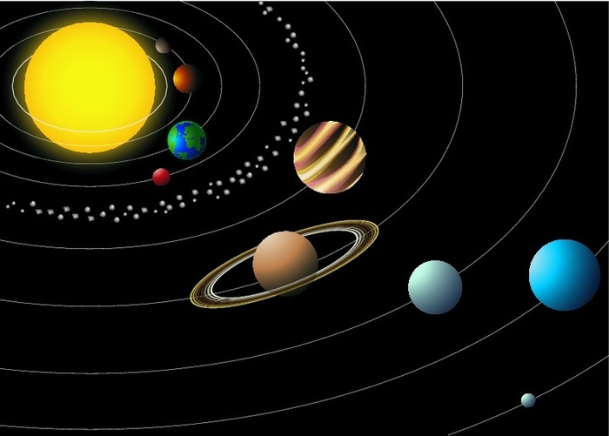
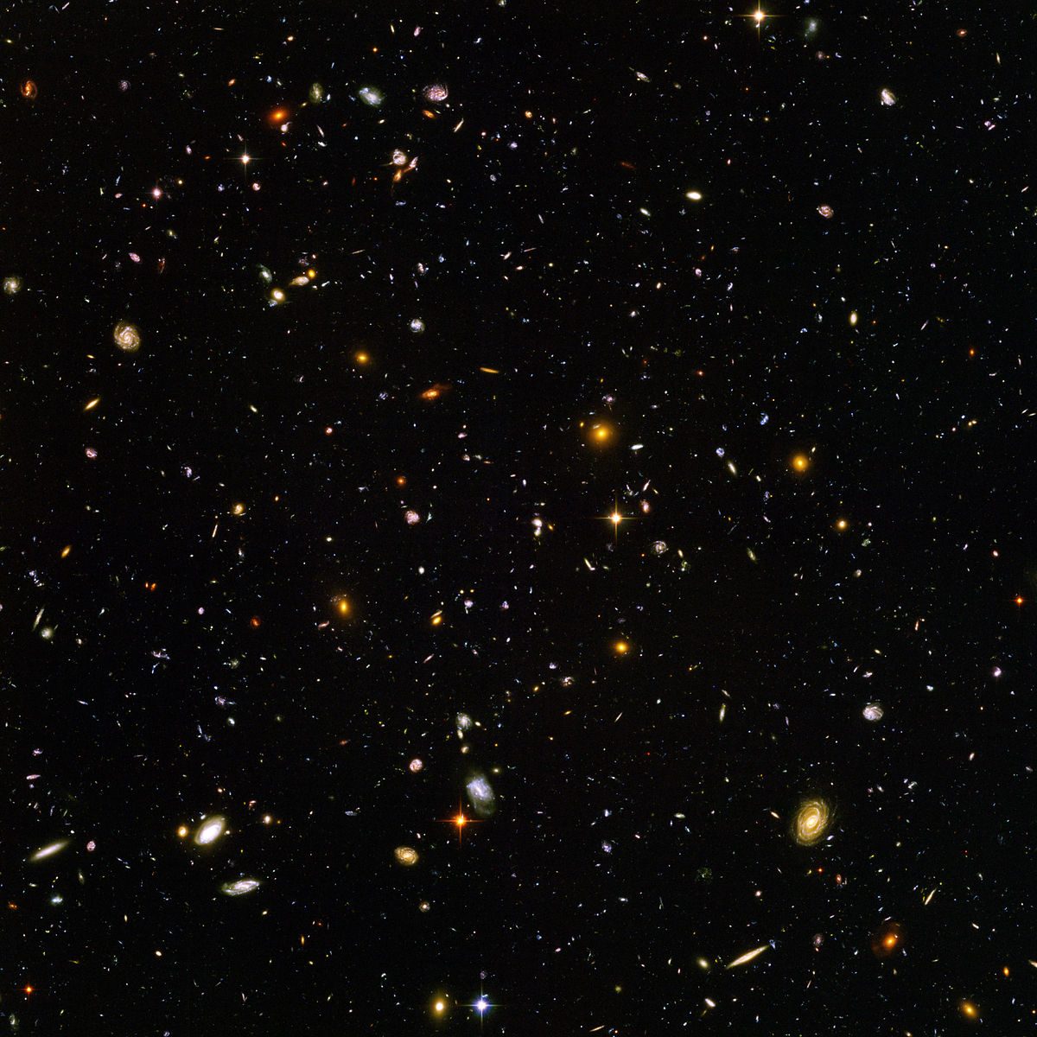


Rhea means Earth. I’m interested in space and planets.
Rea znači Zemlja. Zanimaju me svemir i planete.


My favourite school subject is science.
Moj najdraži predmet je znanost.
I do science tests without any problems.
Rješavam testove s lakoćom.

I would like to be an astronomer.
Voljela bih biti astronom.
Astronomers study planets and stars.
Astronomi proučavaju planete i zvijezde.
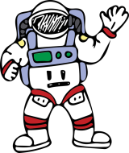

I could be an astronaut, too.
Mogla bih postati i astronaut.
They fly into space.
Oni lete u svemir.

* Rhea wants to be _____________________________ .
(Rhea želi biti…)

d) Match the pictures to the words.
Spoji sličice s riječima koje ih opisuju.
1 astronaut a) 

2 space b)

3 planets c) 

4 science d) 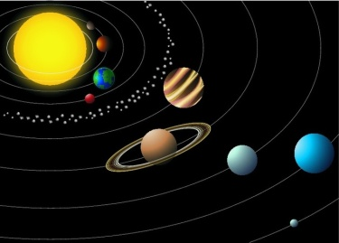

5 astronomer e) 

6 the Earth f) 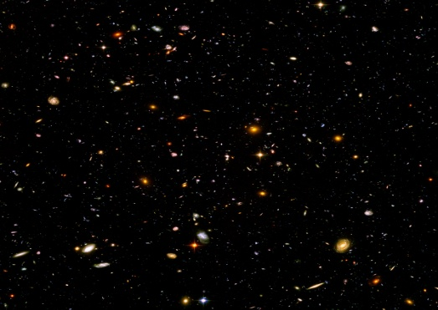

e) Read the text again.
Pročitaj tekst još jednom.

Complete the sentences with the missing words from the frame.
Nadopuni rečenice s riječima iz okvira.

planets stars name science
tests astronomer fly

My name is Rhea.
Moje ime je Rhea.

Rhea means Earth.
Rea znači Zemlja.

I’m interested in space and _____________.
Zanimaju me svemir i planete.

My favourite school subject is ______________ .
Moj najdraži predmet je znanost.

I do science _________ without any problems.
Rješavam testove s lakoćom.

I would like to be an _______________.
Voljela bih biti astronom.

Astronomers study planets and ____________.
Astronomi proučavaju planete i zvijezde.

I could be an astronaut, too.
Mogla bih postati i astronaut.

They __________ into space.
Oni lete u svemir.

- 4
ABEBA
a) Look at the pictures.
Pogledaj sličice.
Where does Abeba come from?

Odakle je Abeba?
b) Listen to your teacher read the text.
Poslušaj svog učitelja kako čita tekst.
c) Read the text together with your teacher.
Pročitaj tekst zajedno sa svojim učiteljem.
What does Abeba want to be?
Što Abeba želi postati kad odraste?

ABEBA

Hello, my name is Abeba. It means a flower .
Bok, moje ime je Abeba. To znači cvijet.

This is a good name for me because I love flowers.
Ovo mi ime pristaje jer volim cvijeće.
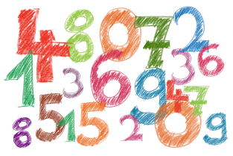

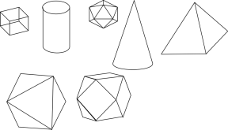

I also love numbers.
They are fascinating.
Također, volim brojeve.
Oni su fascinantni.
Geometry is interesting, too.

Geometrija je također zanimljiva.

Maths is my favourite school subject.
Matematika je moj omiljeni predmet.
I’m very good at it. I never make mistakes in maths.
Jako sam dora u matematici. Nikada ne griješim u matematici.
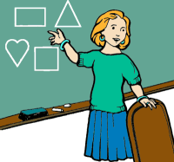
I’d like to be a teacher.
Voljela bih postati učiteljica.

* Abeba wants to be _____________________________ .
(Abeba želi biti…)

d) Write the words that describe the pictures on the empty lines.
Upiši riječi koje opisuju slike na prazne crte.

teacher maths geometry flower numbers

1 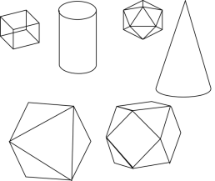 geometry 2 __________

3 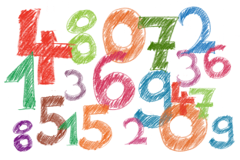___________ 4  ___________

5 ____________

e) Read the sentences. Circle the correct word.
Pročitaj rečenice. Zaokruži točnu riječ u rečenici.

1 Abeba means flower / the Earth.
2 She likes flowers / cats.
3 She loves numbers / science, too.
4 She thinks geometry is boring / interesting.
5 Geography / maths is her favourite subject.
6 Abeba is very good at English / maths.
7 She would like to be a doctor / teacher.

- 5 ROKO
a) Look at the pictures.
Pogledaj sličice.
Where does Roko come from?
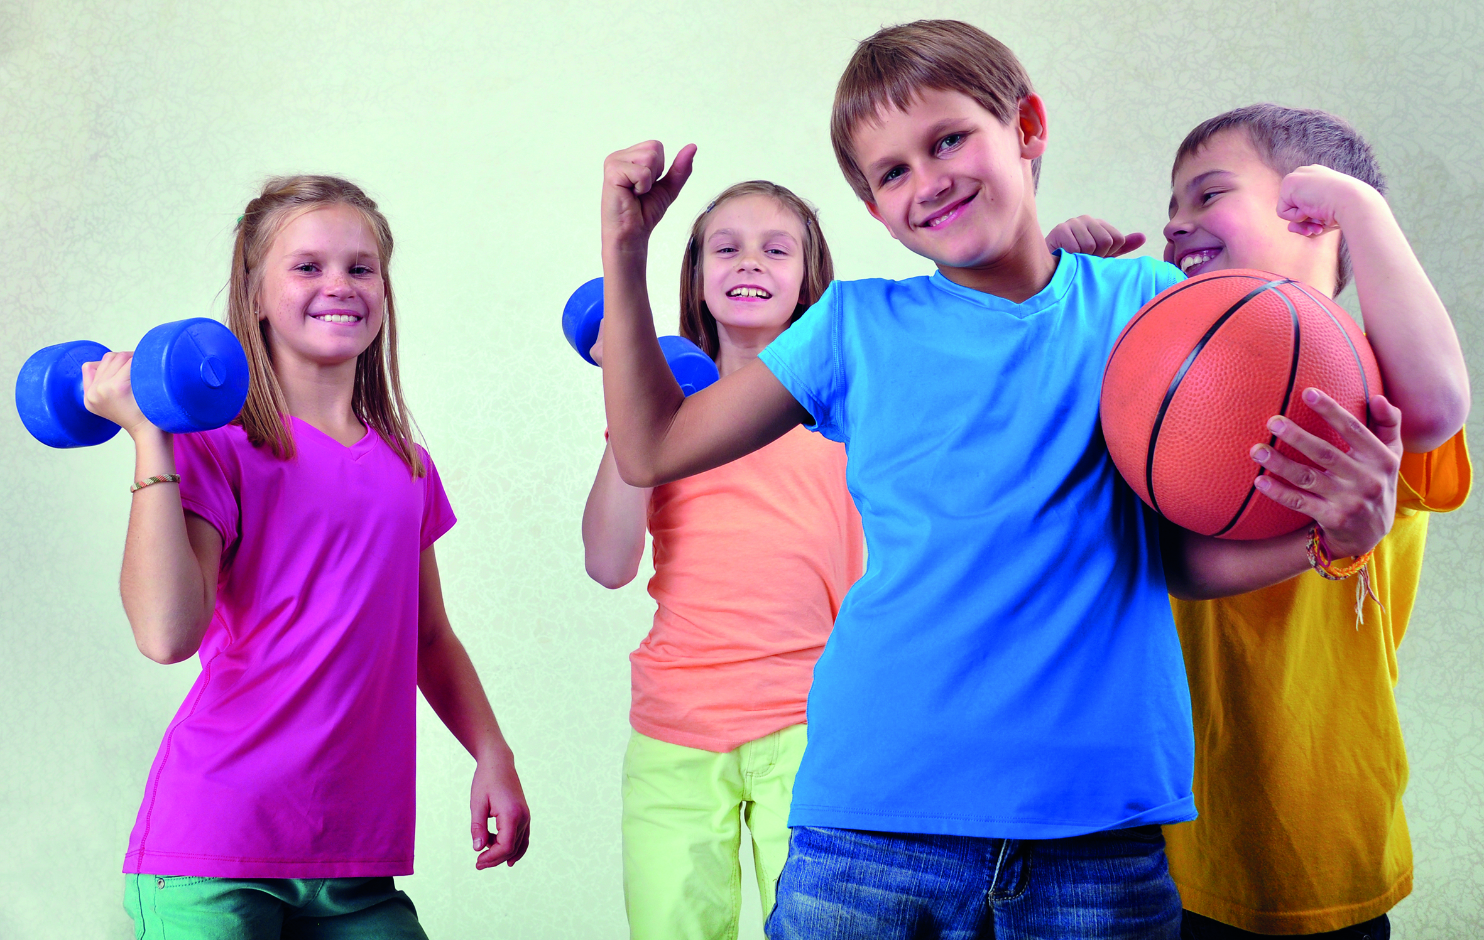
Odlakle je Roko?
b) Listen to your teacher read the text.
Poslušaj svog učitelja kako čita tekst.
c) Read the text together with your teacher.
Pročitaj tekst zajedno sa svojim učiteljem.

ROKO
Hello! Bok! My name is Roko.

Moje je ime Roko.

It means a tall man.
To znači visok čovjek.

I’m not tall but I’m interested in basketball and
Nisam visok, ali me zanimaju košarka i
team sports . 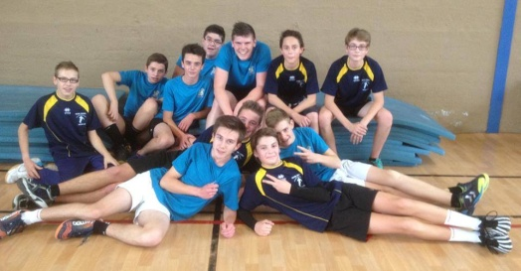
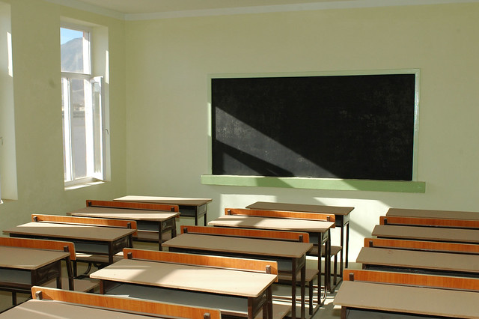
timski sportovi.
I don’t have a favourite subject.
Nemam omiljeni predmet.
I don’t like sitting in the classroom.
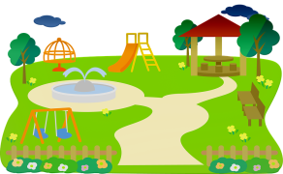
Ne volim sjediti u razredu.

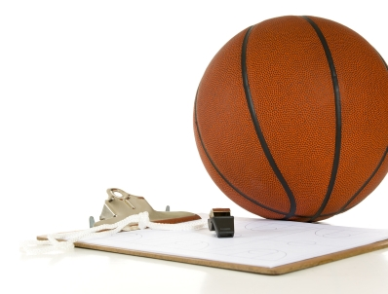
I like projects and outdoor activities.
Volim projekte i aktivnosti na otvorenom (vani).

I would like to be a manager or a basketball coach.
Volio bih postati košarkaški trener ili menandžer.

Roko wants to be _____________________________ .
(Roko želi biti…)

d) Look at the pictures. Read out the words.
Pogledaj sličice. Pročitaj riječi.
Circle the word that describes the picture.
Zaokruži riječ koja opisuje sliku.

1 2  3
tall / short basketball / football sports / cooking

4 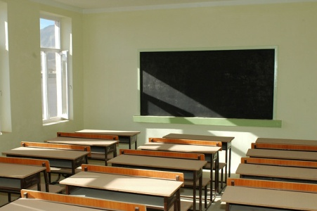 5 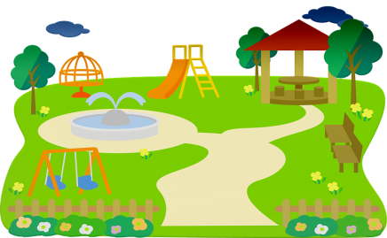
classroom / bedroom outdoors / in the house

e) Read the sentences.
Write YES for a true sentence or NO for a false sentence.
1 Roko means small. NO__
Roko znači malen.

2 He is interested in basketball and sports. _______
Zanima ga plivanje.

3 Roko's favourite subject is Croatian. _______
Roko nema omiljeni predmet.

4 He likes sitting in the classroom. ________
On voli sjediti u učionici.

5 He likes projects and outdoor activities. ________
On voli projekte i aktivnosti na otvorenom.

6 He would like to be a basketball coach or a manager. ________
On bi volio postati košarkaški trener ili menandžer.

- 5 What about you?
Što vrijedi za tebe?

What are you interested in?
Što te zanima?

What are you good at?
U čemu si dobar?

What would you like to be when you grow up?
Što želiš postati kada odrasteš?

Talk to your classmate about your interests.
Ask and anwer the questions above.
Razgovaraj sa svojim razrednim prijateljem o svojim interesima.
Finish the sentences with your own answers.
Dovrši rečenice svojim odgovorima.

1 I am interested in ___________________________ .
( Mene zanima / zanimaju…)

2 I am good at _______________________________ .
(Dobar sam u …)

3 I would like to be ___________________________
when I grow up.
(Napiši što bi volio postati kad odrasteš.)

